1. **System Design**

**7.1 Database Design**

* **tblAdminUser**

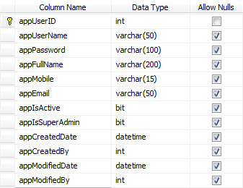

|  |  |  |
| --- | --- | --- |
| **Constraints** | **Name** | **Description** |
| Primary Key | appUserId | This table will store the admin login information. |

* **tblCountry**



|  |  |  |
| --- | --- | --- |
| **Constraints** | **Name** | **Description** |
| Primary Key | CountryId | This table will store the Country information. |

* **tblstate**

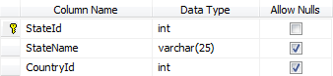

|  |  |  |
| --- | --- | --- |
| **Constraints** | **Name** | **Description** |
| Primary Key | StateId | This table will store the information about the State. |
| Foreign Key | CountryId  (Reference To Country table) |

* **tblCity**

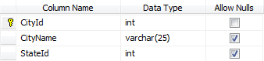

|  |  |  |
| --- | --- | --- |
| **Constraints** | **Name** | **Description** |
| Primary Key | CityId | This table will store the information about the City. |
| Foreign Key | StateId  (Reference To State table) |

* **tblArea**

C:\Users\BBC\AppData\Local\Temp\SNAGHTML31a9b7.PNG 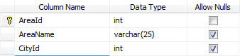

|  |  |  |
| --- | --- | --- |
| **Constraints** | **Name** | **Description** |
| Primary Key | AreaId | This table stores the data about the Area. |
| Foreign Key | CityId  (Reference To City table) |

* **tblBuilding**

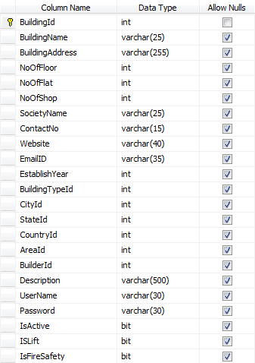

|  |  |  |
| --- | --- | --- |
| **Constraints** | **Name** | **Description** |
| Primary Key | BuildingId | This table stores all the information about the Building.  When Builder add his/her Building information then it added to this table. |
| Foreign Key | CityId  (Reference To City table) |
| Foreign Key | StateId  (Reference To State table) |
| Foreign Key | CountryId  (Reference To Country table) |
| Foreign Key | CountryId  (Reference To Country table) |
| Foreign Key | CountryId  (Reference To Country table) |
| Foreign Key | CountryId  (Reference To Country table) |

* **tbl** **Builder**

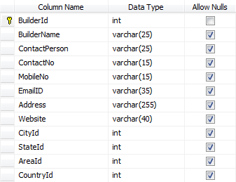

|  |  |  |
| --- | --- | --- |
| **Constraints** | **Name** | **Description** |
| Primary Key | BuilderId | This table stores all the information about the Builder.  When Builder add his/her Builder information then it added to this table. |

* **tblBuildingType**

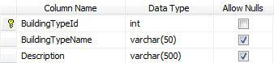

|  |  |  |
| --- | --- | --- |
| **Constraints** | **Name** | **Description** |
| Primary Key | BuildingTypeId | This table will store the BuildingType Inforamation. |

* **tblShop**

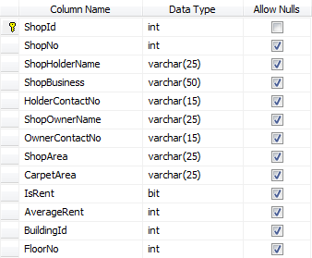

|  |  |  |
| --- | --- | --- |
| **Constraints** | **Name** | **Description** |
| Primary Key | ShopId | This table stores the information about the Shop . |

* **tbl** **Receipt**

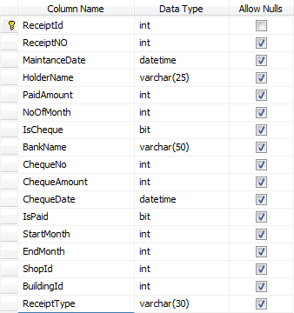

|  |  |  |
| --- | --- | --- |
| **Constraints** | **Name** | **Description** |
| Primary Key | ReceiptId | This table stores the information about the Receipt . |

* **tblServiceType**



|  |  |  |
| --- | --- | --- |
| **Constraints** | **Name** | **Description** |
| Primary Key | ServiceTypeId | This table stores the information about the serviceType . |

* **tblServiceProvider**

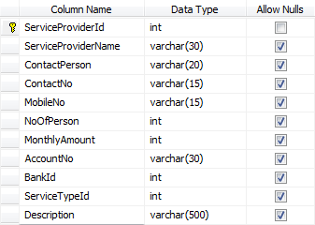

|  |  |  |
| --- | --- | --- |
| **Constraints** | **Name** | **Description** |
| Primary Key | ServiceProvider | This table stores the information about the seviceProvider . |
| Foreign Key | BankId  (Reference To Bank table) |  |
| Foreign Key | ServiceTypeId  (Reference To ServiceType table) |

* **tblAdvertise**

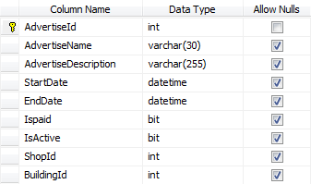

|  |  |  |
| --- | --- | --- |
| **Constraints** | **Name** | **Description** |
| Primary Key | AdvertiseId | This table stores the information about the Advertise . |
| Foreign Key | BuildingId  (Reference To Building table) |

* **tbl** **Committee**

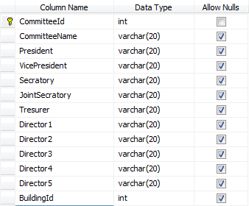

|  |  |  |
| --- | --- | --- |
| **Constraints** | **Name** | **Description** |
| Primary Key | CommitteeId | This table stores the information about the Committee. |
| Foreign Key | BuildingId  (Reference To Building table) |

* **tbl** **Voucher**

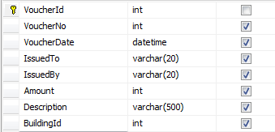

|  |  |  |
| --- | --- | --- |
| **Constraints** | **Name** | **Description** |
| Primary Key | VoucherId | This table stores the information about the Voucher . |
| Foreign Key | BuildingId  (Reference To Building table) |  |

* **tbl** **Income**

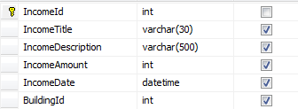

|  |  |  |
| --- | --- | --- |
| **Constraints** | **Name** | **Description** |
| Primary Key | IncomeId | This table stores the information about the Income . |
| Foreign Key | BuildingId  (Reference To Building table) |  |

* **tbl** **Exapance**

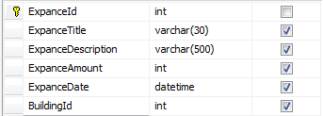

|  |  |  |
| --- | --- | --- |
| **Constraints** | **Name** | **Description** |
| Primary Key | exapanceId | This table stores the information about the Exapance. |
| Foreign Key | BuildingId  (Reference To Building table) |  |

1. **Directory Structure**

* **Administration Structure :**
* **Admin**

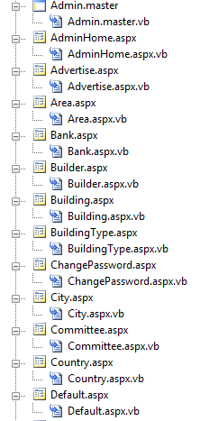

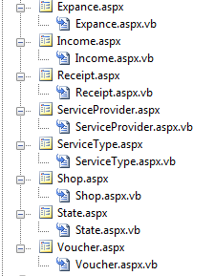

* **Common Css**

**C:\Users\BBC\Desktop\image\css.png**

* **Common JavaScript**

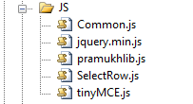

* **Client Structure :**
* **Client**

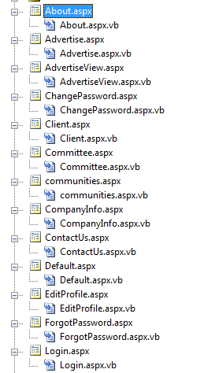

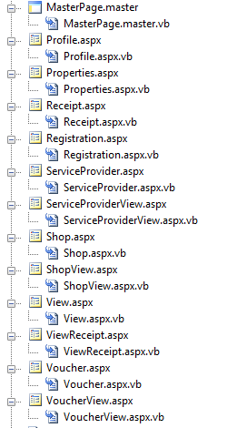

* **Common Css**

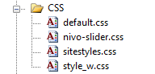

* **Common Javascript & JQuery**

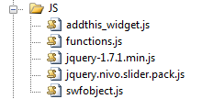

**7.3 Input Design**

* **Home Page :**

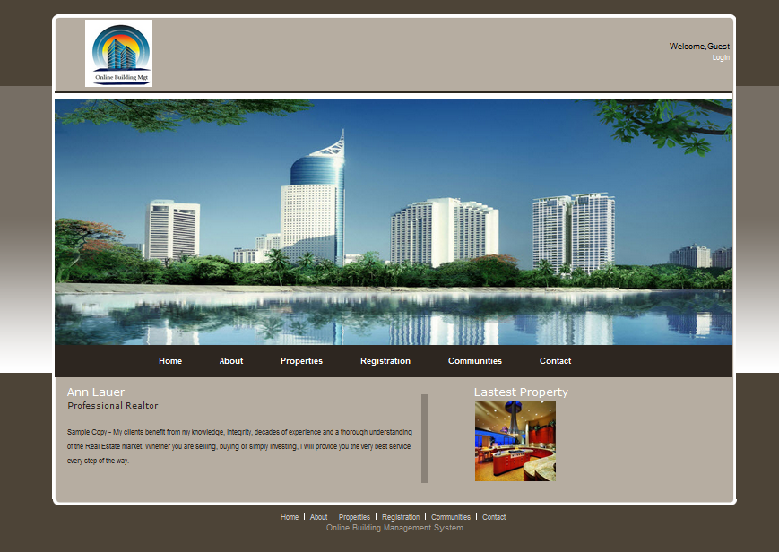

* **Login page :**

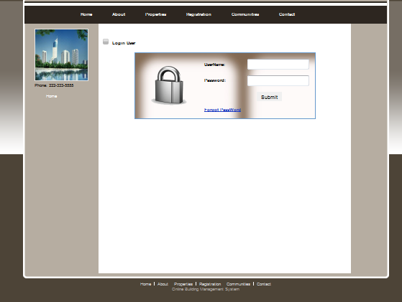

* **Registration page :**

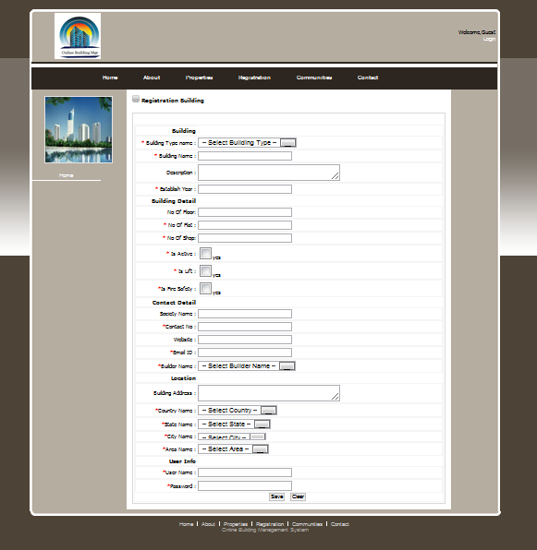

* **Change spassword page :**

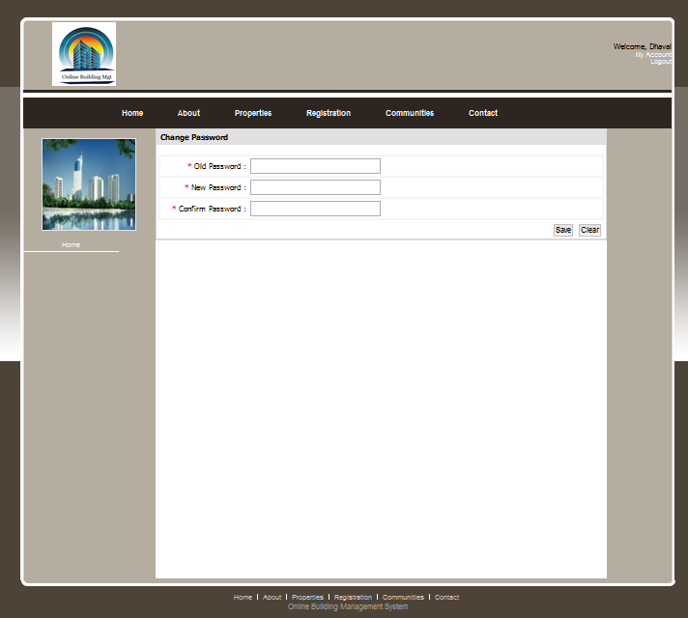

* **My profile page :**

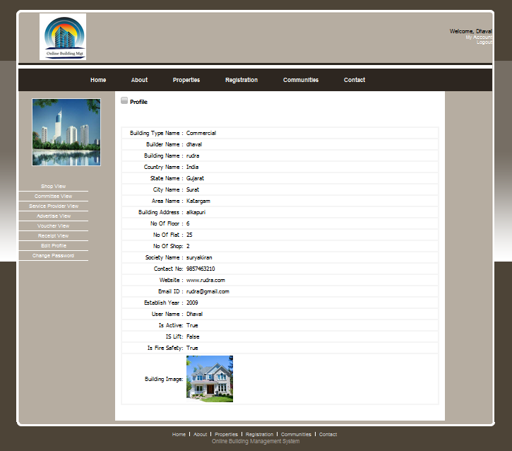

* **Profile Add page :**

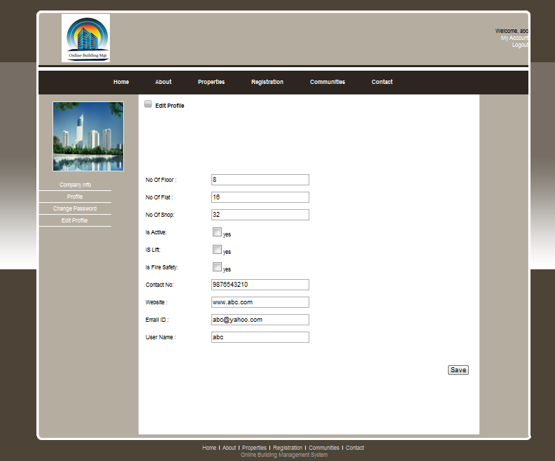

* **Shop View Page :**

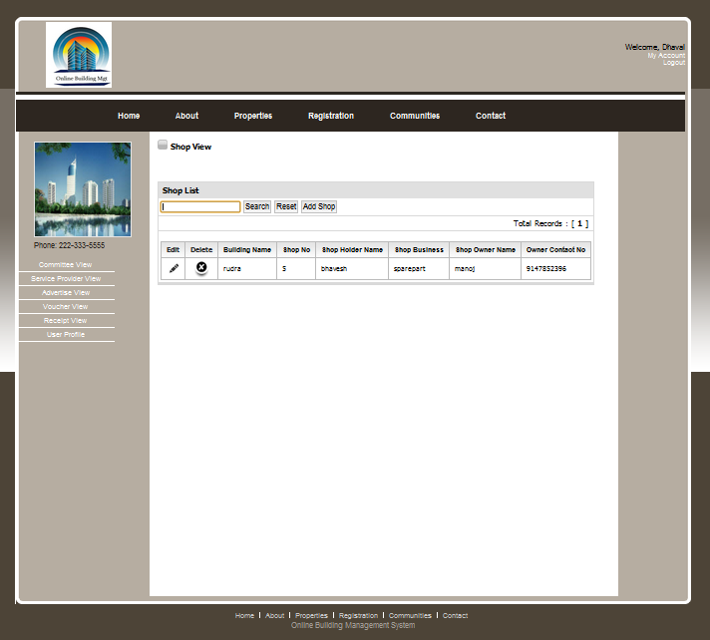

* **Shop Add Page:**

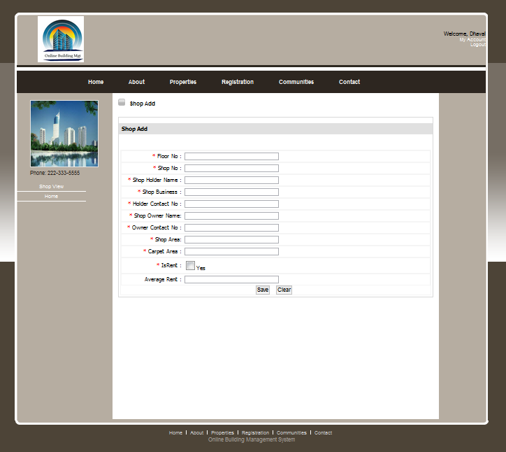

* **Advertise View Page :**

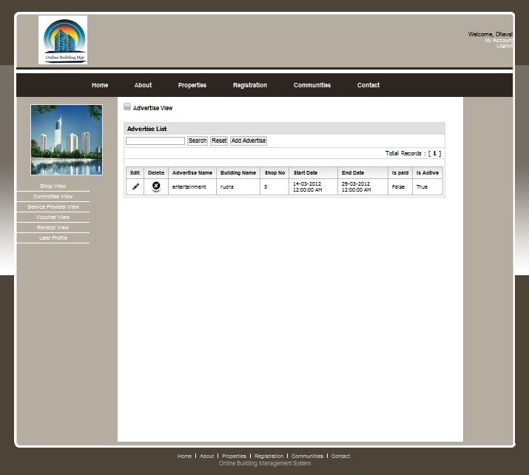

* **Advertise Add Page:**

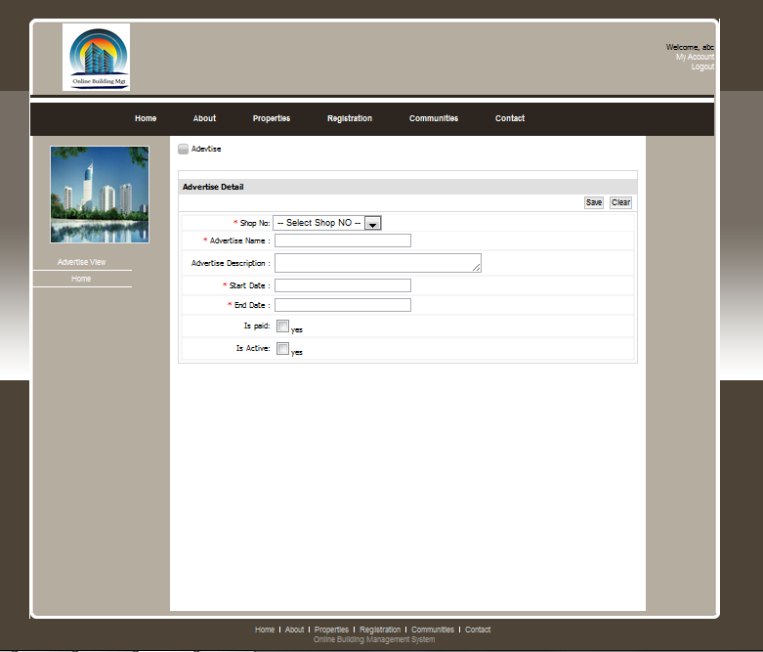

* **Service View Page:**

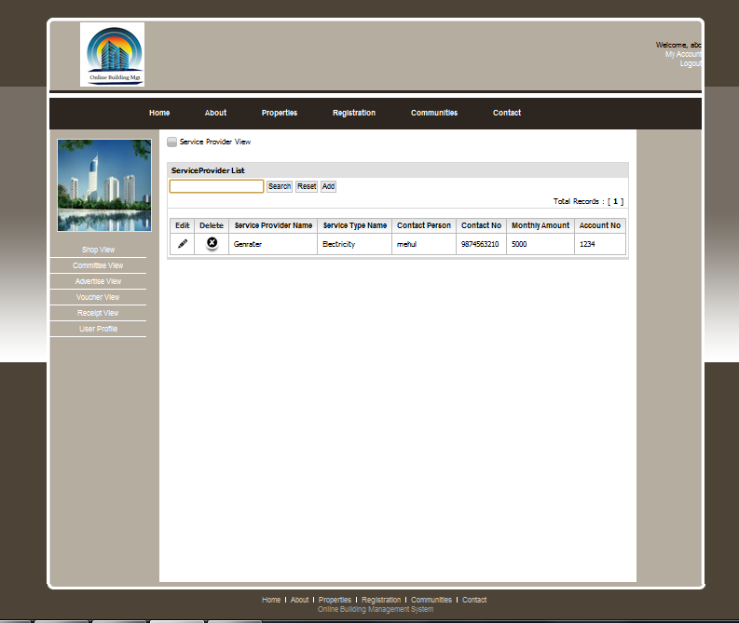

* **Service Add Page:**

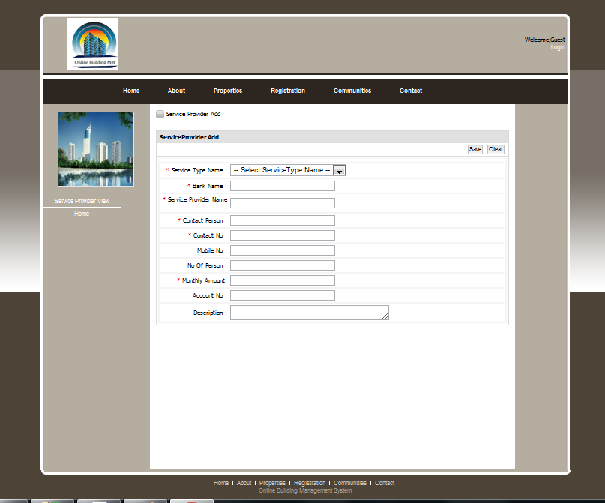

* **Receipt View Page:**

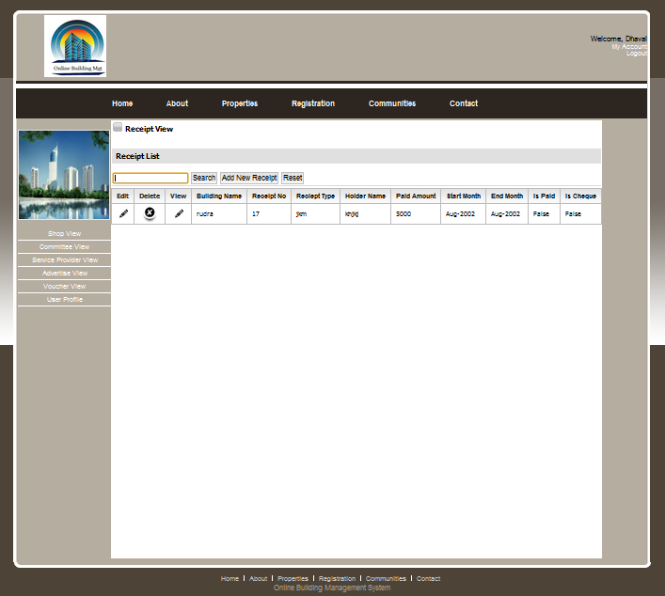

* **Receipt Add Page:**

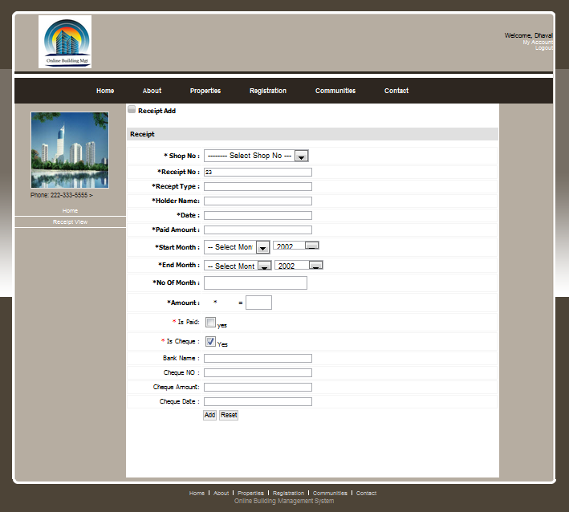

* **Voucher View page :**

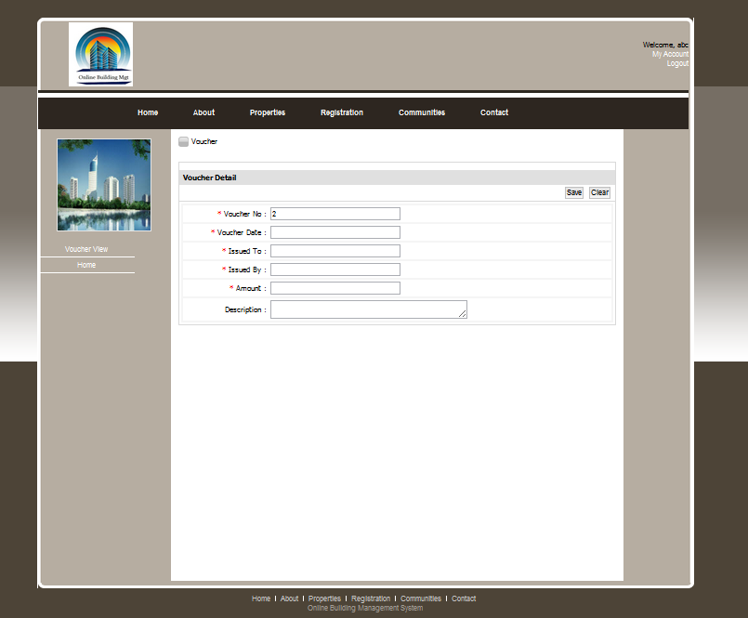

* **Print Receipt page :**

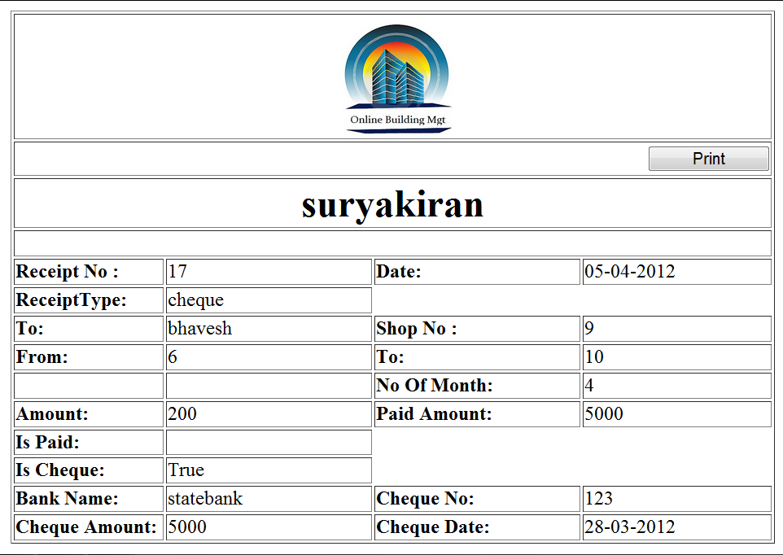

* **Login Page (Admin) :**

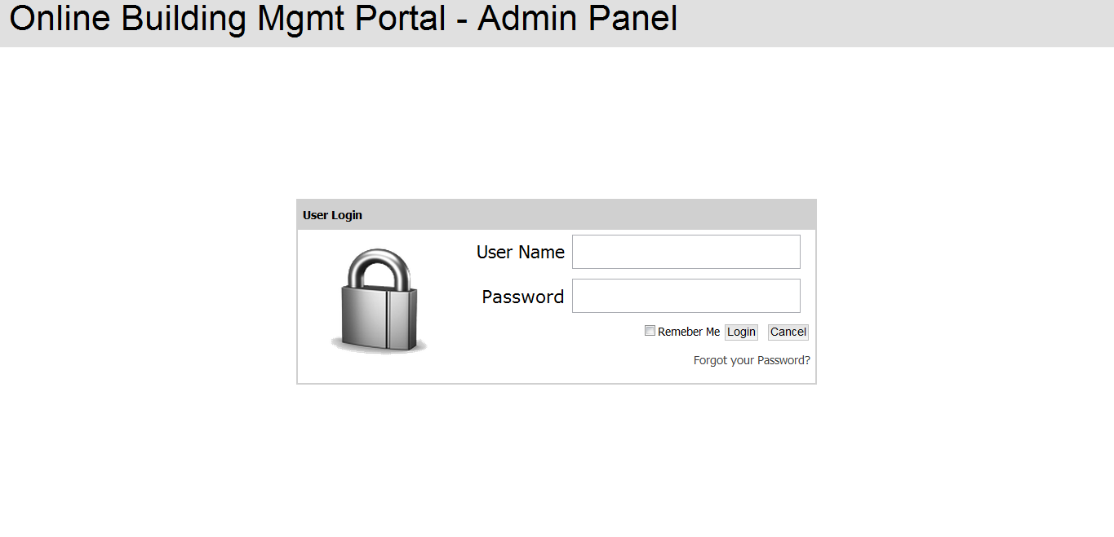

* **Change Password Page (Admin) :**

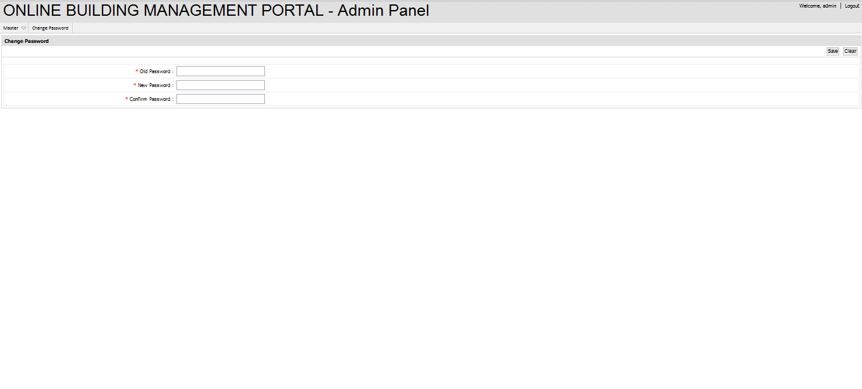

* **Building Page (Admin) :**

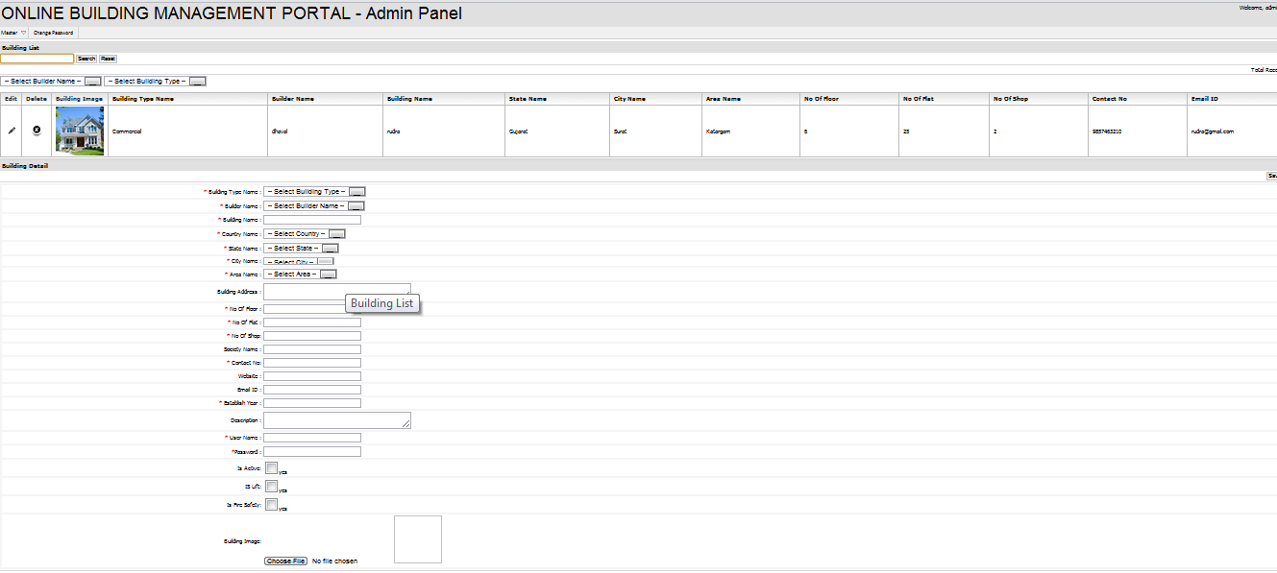

* **Country (Admin) :**

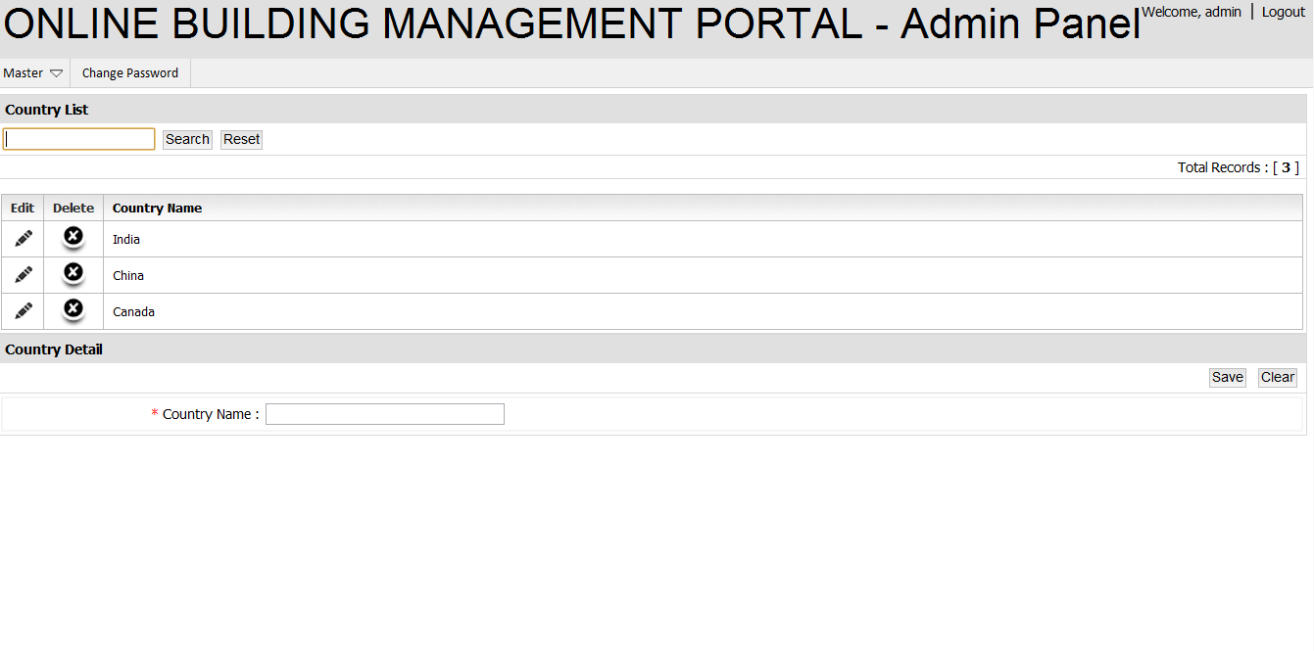

* **City (Admin) :**

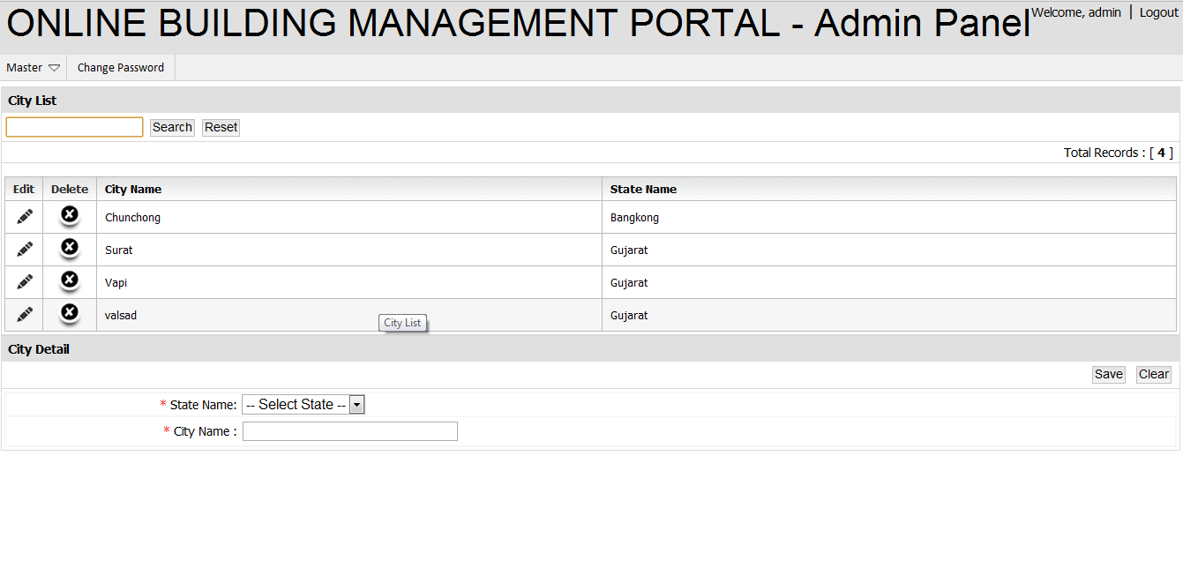

* **State (Admin) :**

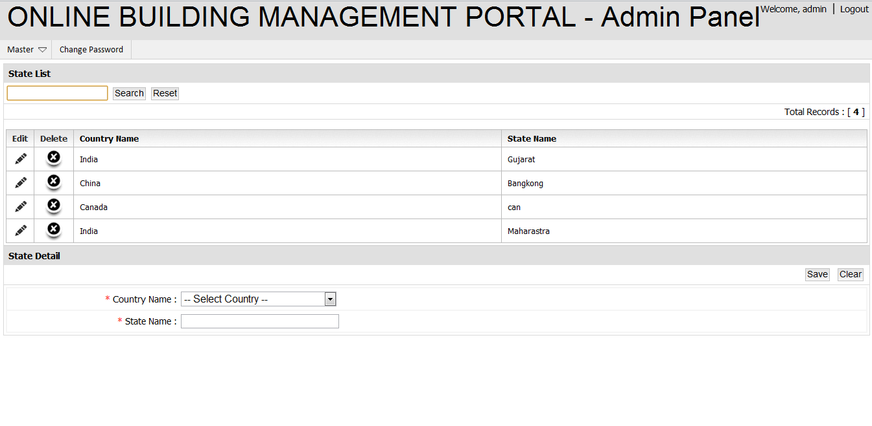

* **Area (Admin) :**

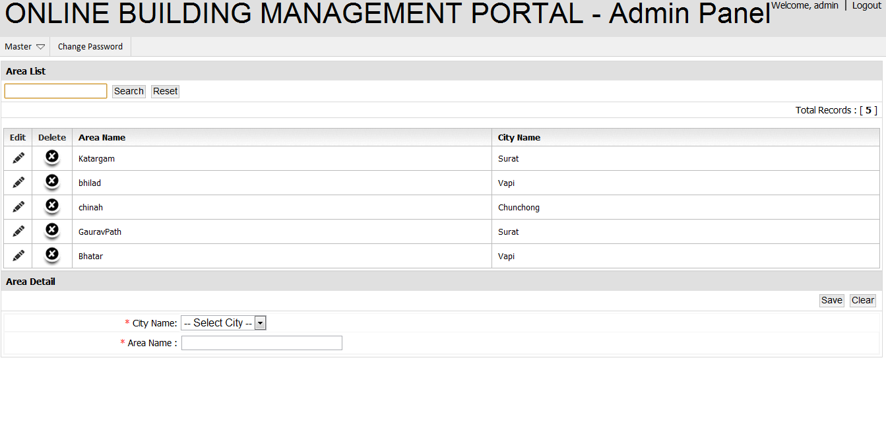

* **Builder Page (Admin) :**

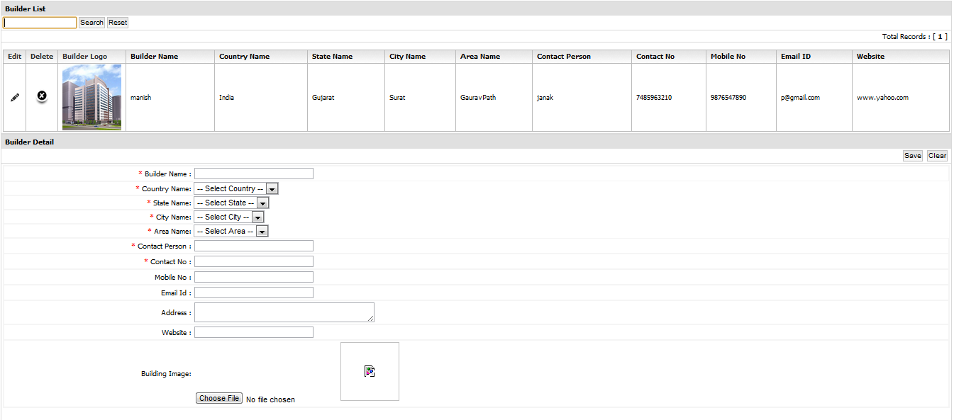

* **Shop Page (Admin) :**

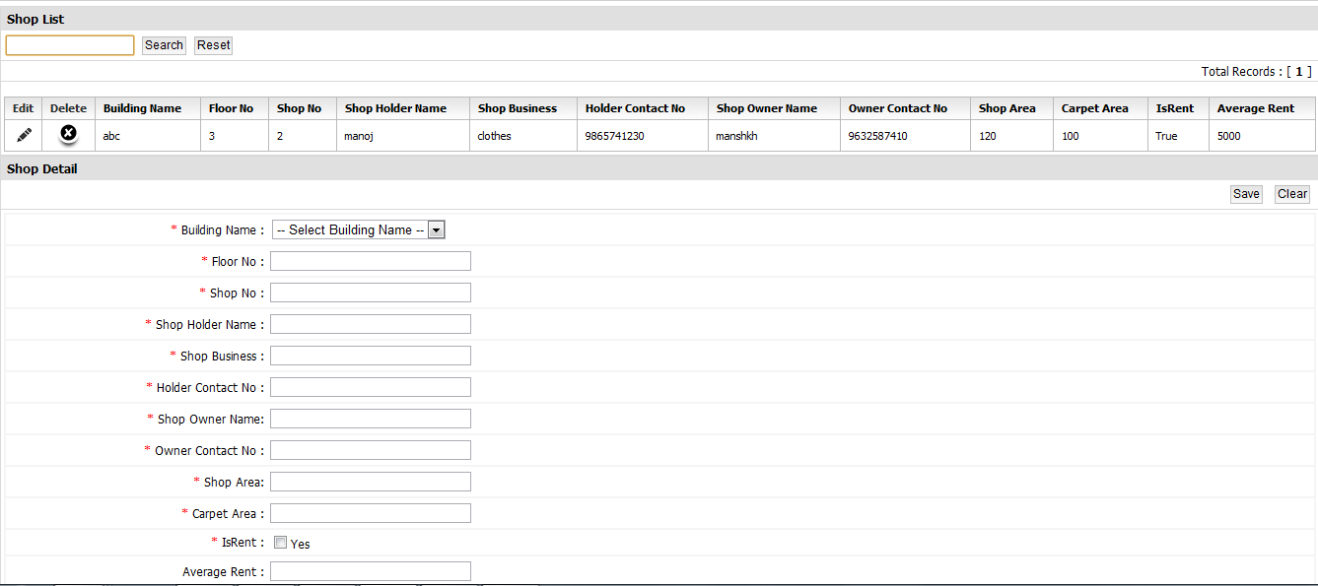

* **Advertise Page (Admin) :**

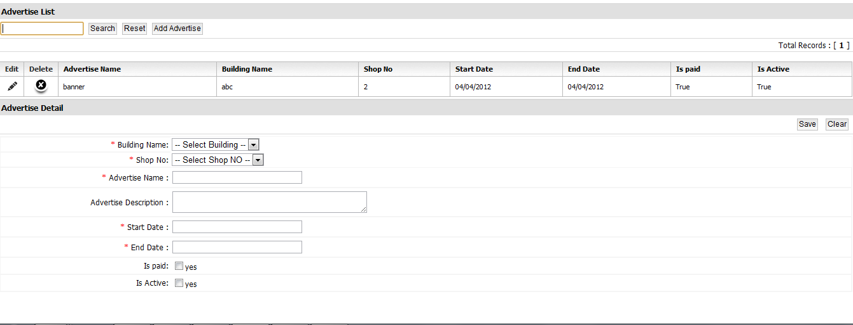

* **Committee Page (Admin) :**

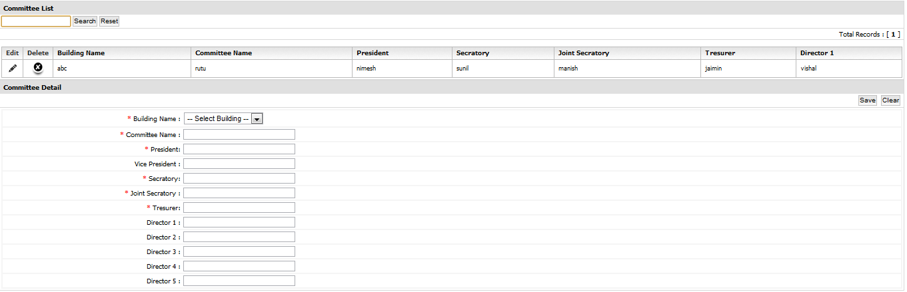

* **Voucher Page (Admin) :**

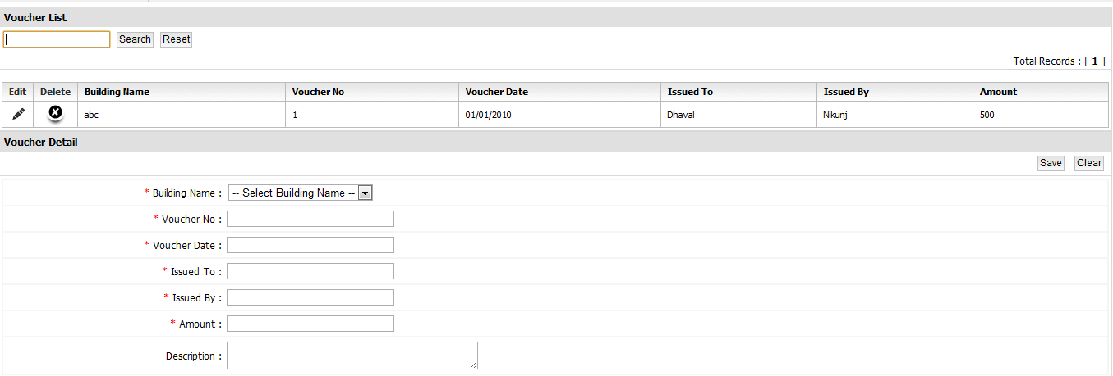

**7.4 Output Design**

* **Login Required :**

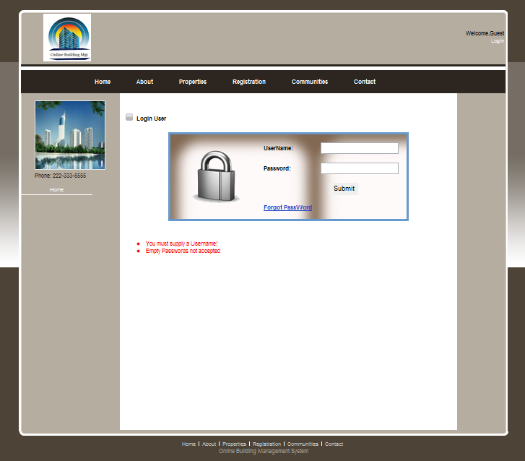

* **Registration Validation :**

